Ms. M. Paula Raposa Treasurer
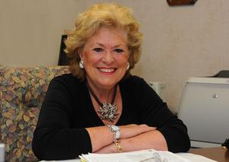
Ms. Raposa is the former Executive Director of Southeastern Massachusetts SER- Jobs for Progress Inc. since 1978. SER is a community-based non-profit organization, providing education, skills training and job development services. Born in S. Miguel, Azores she immigrated to Fall River in 1960. She is past president of the Fall River Rotary Club, past Assistant Governor for District 7950 Rotary International, past Chair Fall River Chamber of Commerce, Trustee Bank Five, Past Director Southcoast Hospitals, founding member of Ateneu Luso Americano and also serves on the Bristol County Workforce Investment Board. She attended Bristol Community College, Bank Street College and Roger Williams University.

